Russell Buck
CS 255 System Analysis and Design
6-3 assignment Interpreting UML Diagrams
February 15, 2026

Interpretation of the UML Activity and Sequence Diagrams
The UML activity and sequence diagrams both describe the same use case: a customer withdrawing cash from an ATM. The activity diagram presents the high‑level workflow, beginning with verifying the user’s PIN, then requesting the withdrawal amount, checking whether the amount is available, dispensing cash, and finally generating and printing a receipt. The sequence diagram focuses on the interactions among the User, the ATM, and the Bank. It shows the user inserting a card, entering a PIN, and the ATM sending that PIN to the bank for verification. Once the bank confirms the PIN is valid, the ATM asks for the withdrawal amount, the user enters it, and the ATM dispenses cash. Together, these diagrams illustrate both the overall process flow and the detailed message‑passing required to complete a basic ATM withdrawal.

Deficiencies in the Current Design
1. Missing handling of invalid or unavailable withdrawal amounts in the sequence diagram
The activity diagram includes a decision point for whether the requested amount is available, but the sequence diagram does not show any interaction with the bank to validate the amount. It also does not show what happens if the amount exceeds the account balance or the ATM’s available cash. This inconsistency leaves out an essential part of real ATM behavior.
2. No support for multiple PIN attempts or card retention
Both diagrams treat an incorrect PIN as an immediate end to the process. Real ATMs allow multiple attempts before canceling the transaction and may retain the card after repeated failures. The absence of retry logic oversimplifies the security process and does not reflect realistic ATM functionality.
3. Missing receipt printing and card return in the sequence diagram
The activity diagram includes “Generate Receipt” and “Print Receipt,” but the sequence diagram ends after dispensing cash. It also does not show the ATM returning the card to the user. These omissions mean the sequence diagram does not fully represent the complete user experience or the system’s responsibilities.
Improved UML Diagram
To address these deficiencies, I reconstructed the sequence diagram to include proper error handling, PIN retry logic, receipt printing, and card return. This improved version aligns with realistic ATM behavior and matches the branching logic shown in the activity diagram.
Below is the UML sequence diagram:
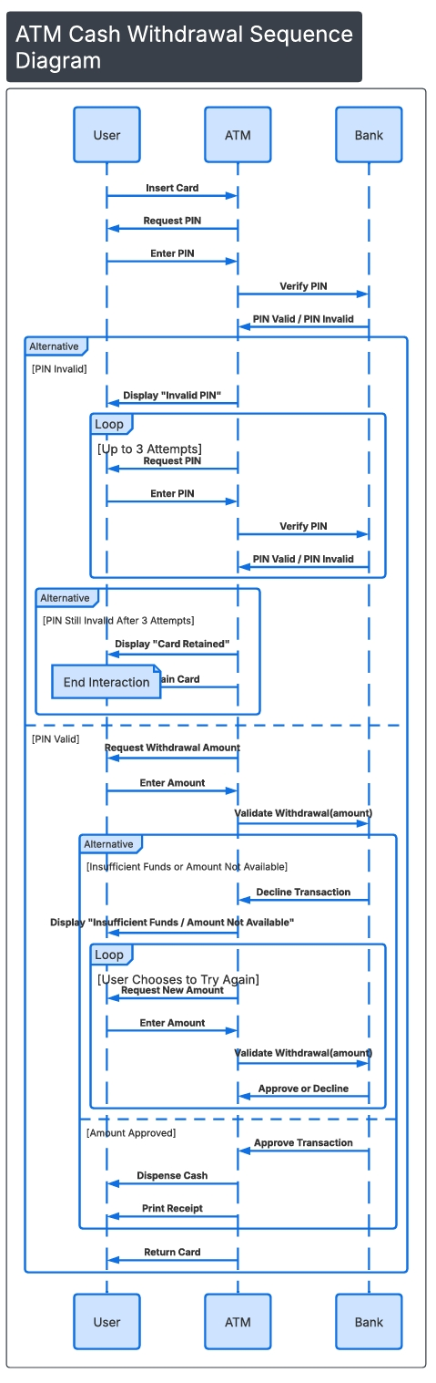
Improved UML Sequence Diagram (Text‑Based Layout)
Participants: User, ATM, Bank

Explanation of Improvements
This revised sequence diagram corrects the inconsistencies between the original diagrams and adds realistic system behavior. It incorporates multiple PIN attempts, card retention after repeated failures, validation of the withdrawal amount, looping logic for insufficient funds, and the final steps of printing a receipt and returning the card. These enhancements create a more complete and functional representation of how an ATM interacts with both the user and the bank during a withdrawal transaction.

